Help - Applications

Page / - last modified by Bimit Administrator on 03.02.2022, 10:17

Applications
last modified by Bimit Administrator
on 03.02.2022, 10:17

Table of Contents
Examples

Create your application
Define the structure of your data, customize it and create the application you want.
App Within Minutes helps you build applications without having technical knowledge.
Try it! Demo
× Create your application
Close

Browse applications
Choose from community contributed applications and install them inside your wiki.
Extension Manager helps you manage (install, update, uninstall) your applications.
Browse
× Browse applications
Close

Examples
Need help or confused with some of our applications? Check out their documentation and find out more about their functionality.
Blog
Blog Application allows you to publish your information and share it to the world.
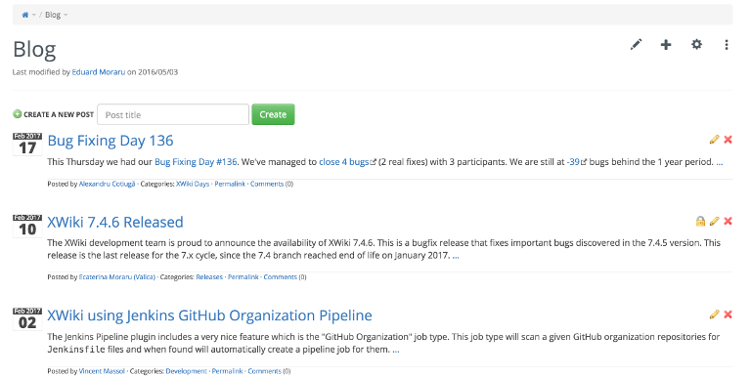
Forum
Forum Application allows you to create new categories and discuss topics within them.
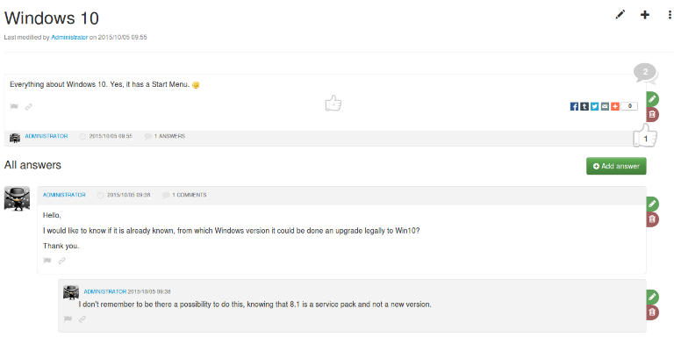
Menu
Menu Application helps you create navigation menus and displayed them in your instance.
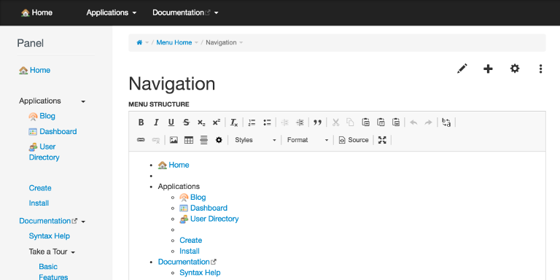
Ideas
Ideas Application encourage you to submit ideas that can be voted by your team.
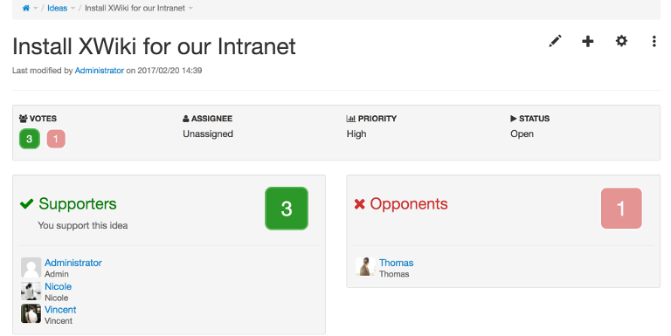
Meetings
Meetings Application manages your meetings mentioning the date, location, participants, etc.
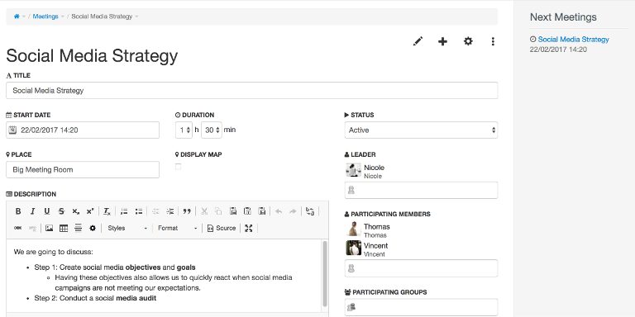
File Manager
File Manager manages your files, providing a viewer of supported files, tag cloud and allowing filtering.
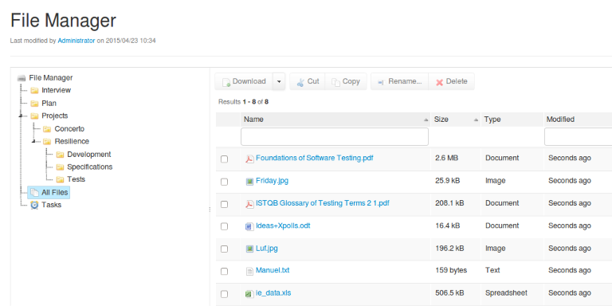
View more applications

